Comprehensive Power BI Analysis of India's Lok Sabha Elections 2024
Author: Charvi Agarwal
Sap ID: 500123403
Roll no: R2142231186
Course: B. tech CSE
Specialization: Data Science
Batch: 7
Project Description
The project builds an interactive Power BI reporting solution to analyse India’s Lok Sabha Elections 2024. The objective is to provide multi-level insights – national, state and constituency/candidate – and to enable simple anomaly detection using counted vs polled audit data. The report consists of three finished dashboards (National Overview, State Insights, Candidate and Party Performance) and a planned Audit/Anomaly dashboard.
The dashboards are interactive and let users filter by State, Constituency and Candidate. They are designed for political analysts, journalist, researchers, election administrators and learners who want to explore turnout patterns, party seat distribution, victory margins and candidate-level performance.
Dataset and Conceptual Data Model
Datasets used are as follows:
- eci_data_2024.csv: Candidate-level facts such as Candidate Name, Party Name, EVM votes, postal votes, total votes, % of votes, state, constituency
- GE India 2024.xlsx: Contains Final Result, Victory Margins, Counted vs Polled sheets
- phase_data.xlsx: From Phase 1 to Phase 7 sheets containing State, Constituency, Electors, Poll%, Count of Votes
Tables Created inside Power BI are as follows:
- Dim_Constituency – master constituency dimension (ConstituencyKey join key to ensure consistent join across phase and results sheets, State, ConstituencyName)
- fact_all_phases – combined Phase 1 to Phase 7 sheets (Electors, Poll%, Count of Votes, Phase)
- Measures_Table – it is acting as a database for storing all the DAX measures
KPIs used in the project
National-level KPIs
- Total Electors = 976M
- Seats Won (total) = 542
- Average Turnout% = 66.55
- Total Votes Polled = 642M
- Total Constituencies = 539
- Sum of EVM Votes = 641M
- Sum of Postal Votes = 4M
- Sum of Total Votes = 645M
State/Margin KPIs
- Close Contests (count < 1000?) = 7784
- Average Victory Margin = 162.23K
- Maximum Victory Margin = 1M
- Minimum Victory Margin = 48
Candidate KPIs
- Total Candidate Votes (contextual) shown = 645M (aggregate shown)
- Candidate Vote share % = 1.00 as displayed
- Victory Margin (card) = 163.23k (displayed in the header)
Audit KPIs (planned)
- Differences > Margin Count
- PostalVotes > Margin Count
- EVM Discrepancy%
Note: additional DAX measures I created are used across visuals – examples such as Total Votes Polled, Turnout%, Seats Won, Total Candidate Votes, Runner Up votes, Candidate Vote Share %, Victory Margin, Close Contest Count etc.
Dashboard Layout and Description
1. National Election Overview
Top row – KPI ribbon (left right):
- Total Electors (976M) | Seats Won (542) | Average Turnout% (66.55) | Total Votes Polled (642M) | Total Constituencies (539) | Sum of EVM Votes (641M) | Sum of Postal Votes (4M) | Sum of Total Votes (645M)
Left column: State slicer (tile buttons) – allows filtering entire page by state.
Main Area (center):
- Turnout% by Constituency – horizontal bar chart (Constituency on Y, Turnout% on X) Shows highest turnout constituencies.
- State table (matrix) – columns: State, Total Constituencies, Total Votes Polled, Turnout %, Seats Won (shows states like Uttar Pradesh, Maharashtra, etc)
- Seats Won by Party – horizontal bar chart (party vs seats) – top parties shown
Bottom row:
Filled map – Turnout % & sum of votes by State (visual geography)
Line chart – Turnout % by (Phase 1…7) showing Trend across phases.
Purpose and Insights: national snapshot – where turnout concentrated which parties won most seats, phase behaviour.
2. State Election Overview
Top area – slicers and KPI cards:
- State slicer tiles
- KPI cards: Close Contests (7784), Average Victory Margin (163.23K), Maximum Victory Margin (1M), Minimum Victory Margin (48)
Main Visuals:
- Top 10 Close Contest (Bar) – smallest victory margins (top 10 ascending) – useful to spot competitive seats.
- Top 10 Landslide Wins (Bar) – largest victory margins (top 10 descending) – identifies landslide constituencies.
- Seats won by party (pie) for selected state.
- Turnout % by Constituency (Tree map) – visual heat showing turnout distribution across constituencies.
- Turnout vs Victory Margin (Scatter) – X = Turnout %, Y = Victory Margin, bubble sized / colored by state – reveals whether higher turnout correlates with larger margins.
- Total EVM Votes and Total Postal Votes by Constituency (Clustered Column) – comparing EVM vs Postal counts at constituency level.
Purpose and Insights: State level diagnosis – competitiveness, landslide behavior, turnout-vs-margin relationship.
3. Candidate and Party Performance
Slicers (left): Constituency and Candidate selection boxes
Header KPI cards:
- Total Candidate Votes (645M shown – aggregated display), Candidate Vote Share% (1.00), Victory Margin (163.23K).
Main visuals:
- Candidate List Table (Matrix) – Candidate, Party, Total Candidate Votes, Candidate Vote share, Total EVM votes and Total Postal votes.
- Candidate Vote share Horizontal bar – shows top candidates in the context.
- Donut chart – Candidate Vote share % by Candidate (very many slices; shows many extremely small shares – consider Top N).
- EVM vs Postal votes (clustered column) – per candidates’ comparison of EVM vs Postal vote counts.
Purpose and Insights: drill – down into candidate performance withing a constituency; compare winner vs runner-up; see EVM vs Postal composition per candidate.

Dashboard Screenshots
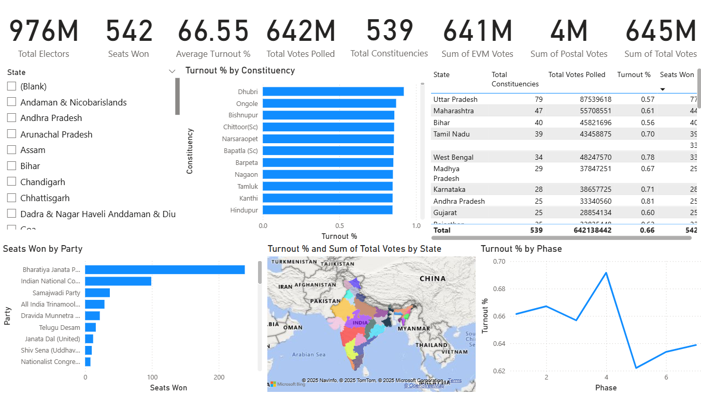
National Election Overview
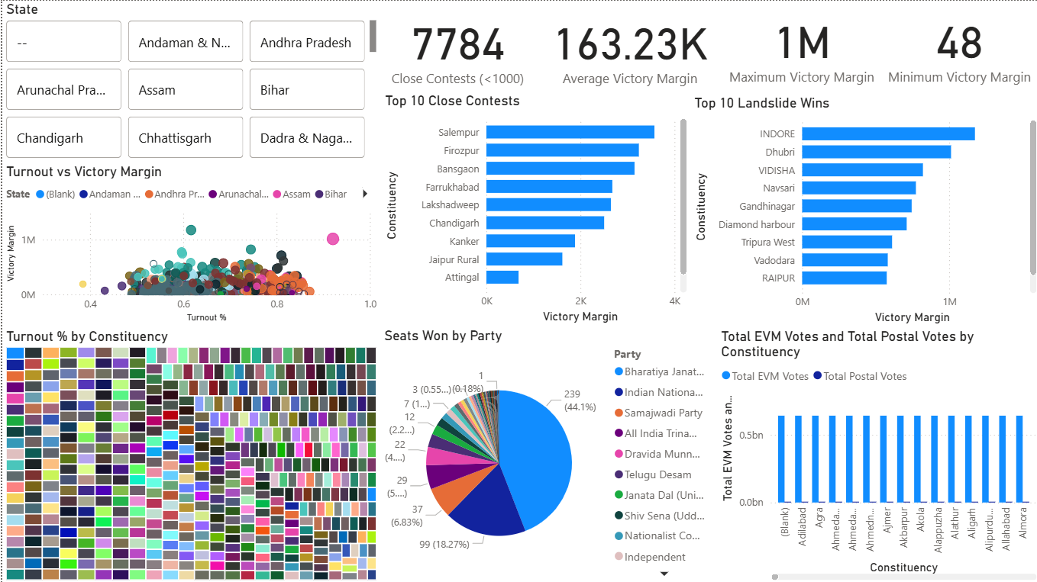
State-Wise Insights
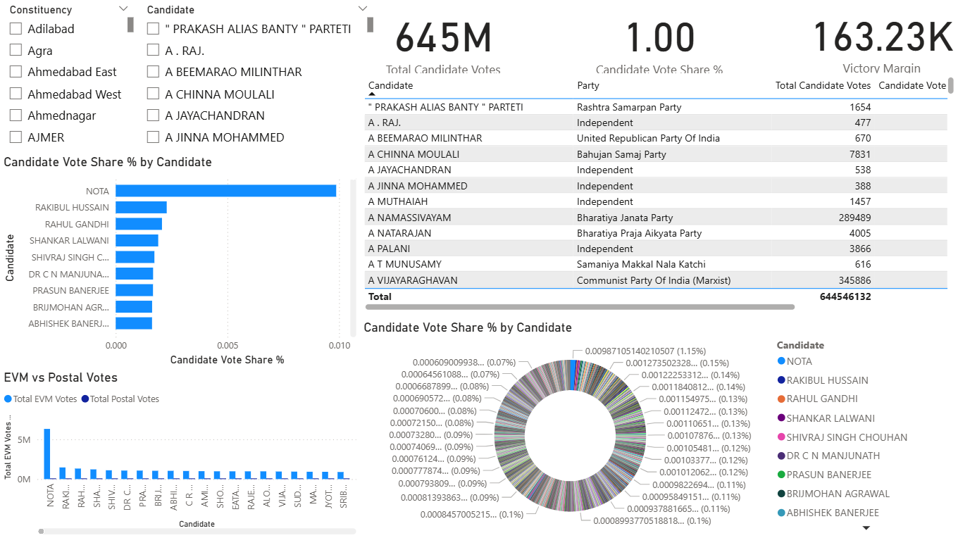
Candidate and Party Performance
Applications of the Developed Dashboard
The practical applications are as follows:
- Election administrators / ECI: detect constituencies where counted vs polled differences exceed victory margins and prioritize audits.
- Political parties / campaign strategists: identify close contest to focus resources and understand strongholds.
- Journalists / analysts: create data-driven stories on turnout trends and party performance.
- Researchers / students: perform further statistical analysis (correlation of turnout vs margin, postal vote impact).
- Public transparency & civic organizations: present accessible visuals on turnout and results.
Conclusion
The Power BI based analysis of the 2024 Lok Sabha Elections transforms raw, multi-sourced electoral data into an interactive and insight-rich decision support system. Through the three completed dashboards – National Overview, State-wise Insights and Candidate and Party Performance – the project provides a comprehensive, layered understanding of voter turnout, party performance, electoral competitiveness and candidate-level dynamics.
The dashboards together deliver macro-level narratives (national turnour, overall seat distribution, phase-wise patterns), meso-level stories (State-specific competitiveness, victory margins, constituency turnout) and micro-level analysis (candidate vote shares, EVM vs postal voting patterns). Each visual is backed by carefully designed DAX measures and clean modelling, ensuring accurate aggregations, dynamic filtering and analytical depth.
Importantly, the project includes a planned Audit/Anomaly dashboard based on Counted vs Polled dataset. Although this 4th dashboard has yet not been implemented, its design is specified and ready to be built: it will enable detection of counting irregularities (for example, where counting differences exceed victory margins or where postal votes could alter outcomes). Adding this Audit dashboard will complete the four-dashboard suite and strengthen the project’s utility for transparency and election oversight.
Beyond academic value, the solution demonstrates how data visualization can support governance, media reporting, political strategy and civic transparency. With the planned audit functionality in place, this project will be positioned to help election administrators and watchdogs identify constituencies that need further verification.
Overall, this project shows proves how Power Bi can convert complex dataset like these into meaningful insights – making democratic outcomes more understandable and transparent for users ranging from election authorities to researchers and the general public.

